2026-2027
Centralia College

Application Packet

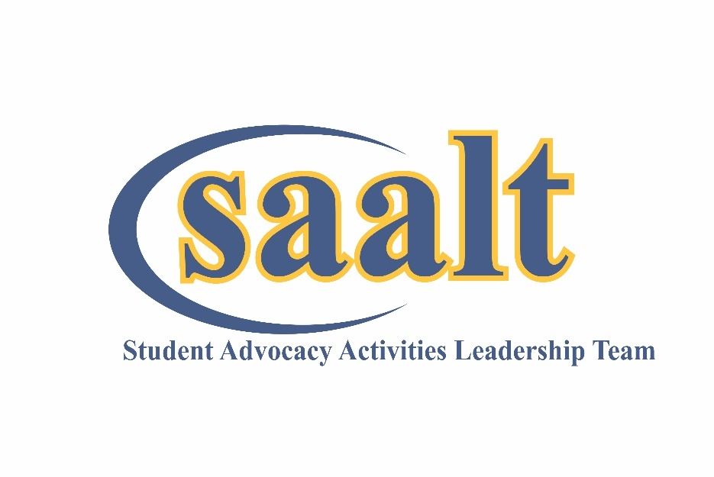

PACKET DUE BY APRIL 29, 2026 by NOON.

First review of applications begins on May 1, 2026.
Positions are open until filled.

2026-27 ASCC Student Advocacy Activities Leadership Team (SAALT)
The Associated Students of Centralia College (ASCC) leadership development program provides opportunities for students to develop effective leadership, communication, and interpersonal skills. SAALT is a group of up to eight students who advocate and plan events for Centralia College students. SAALT is committed to social justice, sustainability and creating inclusive events for all Centralia College students. As the representative for the governing body of Centralia College students, all SAALT members are responsible for advocating for students.

The President, Vice President, and Coordinators on SAALT work together to provide social, cultural, educational and advocacy work through serving on campus committees, being part of the College Shared Governance Model and campus programming.
Individual coordinators may organize or “lead” specific activities or events, however, all members are expected to support and attend all SAALT sponsored events and activities.

QUALIFICATIONS OR ELIGIBILITY:
- While employed on SAALT, be enrolled at Centralia College and in a minimum of 6 college level credits.
- Be in good disciplinary standing with the College.
- Have and maintain a cumulative & quarterly grade point average of 2.5 or higher
- Must submit completed SAALT application (refer to checklist.)

DESIRED SKILLS:
- Interest in legislative issues that impact community and technical college students.
- Experience (volunteer or paid) working in a team environment, organizing events and collaborating with groups.

COMPENSATION:
- Members of SAALT can work up to 15 hours a week and will be paid $17.38 an hour.
- Office hours will be held Monday-Friday between 8 am and 5 pm and flex with evening events.
We are looking forward to meeting you. Please call if we can answer any of your questions. You can reach us at:
Shelley K. Bannish
Director of Student Life & Involvement
shelley.bannish@centralia.edu
360-623-8120

Please return your completed application packet to Shelley K. Bannish in the Student Life and Involvement Center, TransAlta Commons, Room 137 by Noon on April 29, 2026.

Associated Students of Centralia College SAALT

2026 – 2027 SAALT
APPLICATION PACKET COVER SHEET

Name
ctclink #
Local/Cell Phone
Intended Major Cumulative GPA .
Email
CC Graduation Date:

Position(s) Applying For: Check all that apply: Job descriptions available at:
____ President
____ Vice President
____ Coordinator for Executive Affairs
____ Coordinator for Diversity
____ Coordinator for Student Engagement
____ Coordinator for Social Media/Publicity
____ Coordinator for Health & Wellness
____ Coordinator for Civic Engagement

The ASCC Selection/Interview Committee aims to appoint the best person for each position. If you would like to have the option of being considered for a position even if you did not check it above, please indicate by checking “yes” below:

____ Yes, I would like to be considered for other positions

____ No, I would not like to be considered for other positions.

APPLCATION PACKET CHECK LIST
Cover letter and resume
______ Intention to Abide Form
Eligibility and Academic Information Release
Application

Associated Students of Centralia College SAALT

INTENT TO ABIDE FORM

I, , intend to be in school as a full-time student at least two (2) consecutive quarters (excluding summer quarter) immediately following the application quarter; currently have at least 2.5 cumulative G.P.A.; agree to schedule no other activity that would conflict with the regularly scheduled meeting time of the position for which I am applying.

I understand the possibility of penal action and/or disqualification should I fail to abide by the said provisions.

I certify that all the information provided on this application is accurate and true, and acknowledge that any misrepresentation and/or withholding of information may result in rejection of this application or may be considered just cause for discharge if discovered after employment begins. I also understand that incomplete applications may not be considered.

Signature: Date:

ELIGIBILITY AND ACADEMIC INFORMATION RELEASE

Under the provisions of the Family Education Rights and Privacy Act of 1974, my signature gives permission to the Enrollment Services Office at Centralia College to release the academic information listed on the Application to the Director of the Student Life and Involvement Center. I understand my signature gives permission to the Student Life and Involvement Center to release academic information to the ASCC Selection/Interview Committee regarding my G.P.A. and status as a “currently enrolled and continuing student at Centralia College.

Signature: Date:

Selection Process:
All eligible applicants will be contacted for an interview.

Please Note:
- A SAALT member may NOT be employed anywhere else on campus during their term of office.
- When applying for this position, it should be taken into consideration that, barring unforeseen circumstances, you will be required to serve for one school year – that is, summer, fall, winter and spring quarters of the year you applied for employment.
- As with all other employed positions at Centralia College, all potential employees must submit to a background check before being approved to work. Negative history on a background check does not automatically disqualify you from employment.
- The position application is in this packet. In addition to the position descriptions, available online.
- Your employment on SAALT may be reviewed as part of your financial aid package.

APPLICATION ARE DUE BY NOON ON APRIL 29
Commitments as of 4/9/26 DATES WILL BE ADDED AS NEEDED: (Some dates subject to change or cancellation)
- Summer Quarter 2026:
  - Training, Overview and Introductions – August 31-Sept. 18, 2026
  - CUSP Student Leadership Conference – Sept. 9-11, 2026 at Green River College. This is an overnight event.

- Fall Quarter 2026
  - Monday, Sept. 21, 2026; Welcome Day – first day of classes
  - Tuesday, Sept., 22, 2026; Constitution Day and National Voter Registration Day
  - November 12-15; National Association for Campus Activities conference. Santa Clara, CA

Student leaders attend required commitments as part of their development. Expenses for travel to conferences and professional development opportunities (hotel, meals, registration, and transportation) are coordinated and paid by Student Life.

Required Campus Meetings (others committees may be assigned):

President: Institutional Effectiveness 1st Wednesday of the month from 2-4 pm
Board of Trustees Meeting 2nd Thursday of the month 3 -5 pm

Vice President: Budget Review and Planning 2nd & 4th Mondays from 2-4 m
Student Fee Budget Committee – TBD

Coordinator for Curriculum Review 1st and 3rd Mondays from 2-3 pm
Executive Affairs: Instructional Council 1st and 3rd Mondays from 3-4 pm

Coordinator for J.E.D.I. Council 3rd Thursday of each month
Diversity.: Distinguished Alumnus Selection Committee TBD

Coordinator for Inter Club Council once a month, date and TBA
Student Engagement: Facilities Committee last Thursday of the month 2-4 pm

Coordinator for Marketing and Recruitment Team (MART) TBD
Social Media/Pub. Sports Hall of Fame Selection Committee TBD

Coordinator for Foundation Board 2nd Wednesday of the month at 4:30 pm
Health & Wellness Technology Committee 2nd Thursday of the month at 3 pm

Coordinator for Student Policy Council 2nd and 4th Mondays at 2-3:30 pm
Civic Engagement: WACTCSA representative

Everyone: Weekly SAALT meetings Fridays from 8 am to 10 am or 9 am to 11 am

SAALT Application Form
This form is confidential. All fields must be filled in correctly and legibly. Fields that are not filled in or are illegible may delay or exclude the applicant from approval until rectified.

Tell us why you are interested in being on SAALT?

Please list any campus or community activities you are involved with:
Organization/Activity | Position | Dates

Do you have any other commitments during the 2026-27 academic year?
Examples: off campus job, student athlete, clubs and organizations, etc. Please list all.
_______________________________________________________________________________________________________________________________________________________________________________________________________________________________________________________________

Briefly describe your leadership experience:

___________________________________________________________________________________________________________________________________________________________________________________________________________________________________________________________________________________________________________________________________________________________________________________________________________________________________________________________________________________________________________________________________________________________________________________________________________________

